Pace Name______________________________________
Honors English 9 Date__________________________________
Block_____
Antigone &The Odyssey Vocabulary Words
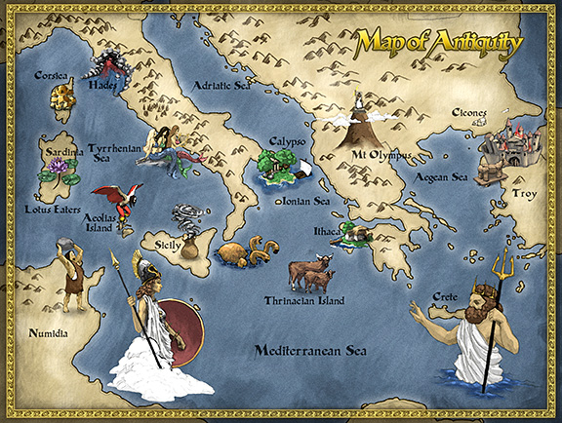
Images found at: http://www.reallycoolblog.com/wp-content/uploads/2012/11/odyssey_map.jpg

Directions: Set up your paper in MLA Format. For each term below, write the definition, being sure to paraphrase the meaning into your own words. List the part of speech for each word. Use the word in an original sentence. This sentence should contain context clues in which you clearly prove you understand the meaning of the word and how it is typically used in our colloquial language.

Example:

Bravado (N) - a bold manner or a show of boldness intended to impress or intimidate
Henry’s false bravado became apparent as he cowered behind his girlfriend as they crept through the haunted house.

- Havoc
- Meritorious
- Impasse
- Ingenious
- (to) buffet
- Libations
- Gall
- Edict
- Retribution
- Insolence
- Impiety
- Consecrate
- Blithe
- Staunch
- Degenerate
- Brazen
- Delude
- Defilement
- Revile
- Transgress
- Augury
- Pomp
- Invocation
- Unbridled
- Formidable

Sign the pledge!

